Nalanda Mahavihara
Nalanda Mahavihara was one of the most important ancient centres of higher education, Buddhist philosophy, science, mathematics, medicine, astronomy, and literature in South Asia. It developed into a large residential learning complex where students and scholars from different parts of Asia came to study.The ancient university was located in present-day Nalanda district of Bihar, India, approximately 90 km southeast of Patna.
Nalanda was a renowned Buddhist mahavihara (great monastery) in medieval Magadha (modern-day Bihar), eastern India.Widely considered to be among the greatest centres of learning in the ancient world and often referred to as "the world's first residential university", it was located near the city of Rajagriha (now Rajgir), roughly 90 kilometres (56 mi) southeast of Pataliputra (now Patna). Operating for almost a thousand years from 427 CE until around 1400 CE, Nalanda mahavihara played a vital role in promoting the patronage of arts, culture and academics during the 5th and 6th century CE, a period that has since been described as the "Golden Age of India" by scholars.The characterisation of Nalanda as a "university" in the modern sense has been challenged by scholars. They argue that while it was undoubtedly a major centre of learning, comparing it directly to a modern university is historically imprecise.
Nalanda was established by emperor Kumaragupta I of the Gupta Empire around 427 CE,and was supported by numerous Indian and Javanese patrons – both Buddhists and non-Buddhists.^{[22][23]} Nalanda continued to thrive with the support of the rulers of the Pushyabhuti dynasty (r. 500–647 CE) and the Pala Empire (r. 750–1161 CE). After the fall of the Palas, the monks of Nalanda were patronised by the Pithipatis of Magadha.Nalanda was attacked by Huns under Mihirakula in the 5th century and again sustained severe damage from an invasion by the Gauda king of Bengal in the 8th Century.During the final invasion it was burnt down by Muhammad Bakhtiyar Khalji (c. 1200), but it managed to remain operational for decades (or possibly even centuries) following his raids.
Over some 750 years, Nalanda's faculty included some of the most revered scholars of Mahayana Buddhism. The historian William Dalrymple said of Nalanda that "at its apex, it was the undisputed scholarly centre of the Mahayana Buddhist world".The faculty and students associated with the monastery included Dharmapala, Nagarjuna, Dharmakirti, Asanga, Vasubandhu, Chandrakirti, Xuanzang, Śīlabhadra, Vajrabodhi, and Dharmasvamin.The curriculum of Nalanda included major Buddhist philosophies like Madhyamaka, Yogachara and Sarvastivada, as well as subjects like the Vedas, grammar, medicine, logic, mathematics,astronomy] and alchemy The mahavihara had a renowned library that was a key source for the Sanskrit texts that were transmitted to East Asia by pilgrims like Xuanzang and Yijing.^{[37]} Many texts composed at Nalanda played an important role in the development of Mahayana and Vajrayana. They include the works of Dharmakirti, the Sanskrit text Bodhisattvacaryāvatāra of Shantideva, and the Mahavairocana Tantra.
The ancient site of Nalanda is a UNESCO World Heritage Site.In 2010, the Government of India passed a resolution to revive the ancient university, and a contemporary institute, Nālandā University, was established at Rajgir.It has been listed as an Institute of National Importance by the Government of India.
Location
Nalanda is about 16 kilometres (10 mi) north of the city of Rajgir and about 90 kilometres (56 mi) southeast of Patna, connected via NH 31, 20 and 120 to India's highway network. It is about 80 kilometres (50 mi) northeast of Bodh Gaya – another important Buddhist site in Bihar. The Nalanda archaeological site is spread over a large area to the northwest of Bargaon (Nalanda) village, and is between the historical manmade lakes Gidhi, Panashokar and Indrapuskarani. On the south bank of the Indrapushkarani lake is the Nava Nalanda Mahavihara – a university founded in its memory.Similarly on the south west bank of the Indrapushkarani lake is Nalanda Open University, the state university named after the ancient Nalanda University.
Etymology
Mahavihara (Mahāvihāra) is the Sanskrit and Pali term for a great vihāra (centre of learning or Buddhist monastery) and is used to describe a monastic complex of viharas.
According to the early 7th-century Tang dynasty Chinese pilgrim, Xuanzang, the local tradition explains that the name Nālandā (Hindi/Magahi: नालन्दा) came from a nāga (serpent deity in Indian religions) whose name was Nalanda. He offers an alternate meaning "charity without intermission", from "na-alam-da"; however, this split does not mean this.^{[46]} Hiranand Sastri, an archaeologist who headed the excavation of the ruins, attributes the name to the abundance of nālas (lotus-stalks) in the area and believes that Nalanda would then represent the giver of lotus-stalks.^{[47]}
In some Tibetan sources, including the 17th-century work of Taranatha, Nalanda is referred to as Nalendra, and is likely synonymous with Nala, Nalaka, Nalakagrama found in Tibetan literature.

History
Nalanda Mahavihara was an ancient centre of learning located in present-day Bihar, India. It was established during the 5th century CE, traditionally associated with the Gupta ruler Kumaragupta I. It developed into a major residential university for Buddhist studies as well as subjects such as logic, grammar, medicine, mathematics and astronomy.
During the 7th century, Nalanda flourished under rulers such as Harshavardhana and attracted scholars from across Asia, including the Chinese traveller Xuanzang. It received further support and expansion under the Pala rulers between the 8th and 12th centuries.
From the late 12th century, Nalanda declined due to political instability, loss of royal patronage and attacks on Buddhist institutions. It was badly damaged during the invasions associated with Bakhtiyar Khalji around the late 12th–early 13th century. The ruins were later excavated and are now protected as an important archaeological site and UNESCO World Heritage Site.

Early development
Nalanda's history goes back to the Gupta period, particularly around the 5th century CE. The institution developed under royal patronage and gradually expanded into a large monastic and educational centre.

Gupta Period
King Kumaragupta I is traditionally associated with the foundation of Nalanda Mahavihara in the 5th century CE.Over subsequent centuries, different rulers provided land, buildings and financial support.

Harsha's Period
During the 7th century, Emperor Harshavardhana became an important patron of Nalanda.The Chinese Buddhist traveller Xuanzang (Hiuen Tsang) visited Nalanda during this period and studied there. His writings provide valuable information about the institution, its scholars and its educational system.

Pala Period
Nalanda experienced significant development under the Pala rulers from approximately the 8th to 12th centuries.The Palas strongly supported Buddhism and established or supported several major centres of learning.Nalanda became connected with other important Buddhist universities and monasteries, including Vikramashila and Odantapuri.

Climate of Nalanda
Nalanda has a humid subtropical climate, typical of much of Bihar.
Summer
- Generally hot
- Temperatures can become quite high
- April–June is the hottest period
- May and June can be particularly hot

Monsoon
- Mainly June–September
- High humidity
- Heavy rainfall occurs during the monsoon
- The landscape becomes considerably greener

Winter
- Generally cool and dry
- November–February is the cooler period
- December and January can have cool mornings and nights
Early history of the city of Nalanda (1200 BCE–300 CE)
Archaeological excavations at sites near Nalanda, such as the Juafardih site about three kilometres away, have yielded black ware and other items. These have been carbon dated to about 1200 BCE. This suggests that the region around Nalanda in Magadha had a human settlement centuries before the birth of the Mahavira and the Buddha.^{[49]}
Early Buddhist texts state that Buddha visited a town near Rajagriha (modern Rajgir – the capital of Magadha) called Nalanda on his peregrinations.He delivered lectures in a nearby mango grove named Pavarika and one of his two chief disciples, Shariputra, was born in the area and later attained nirvana there.These Buddhist texts were written down centuries after the death of the Buddha, are not consistent in either the name or the relative locations. For example, texts such as the Mahasudassana Jataka states that Nalaka or Nalakagrama is about a yojana (10 miles) from Rajagriha, while texts such as Mahavastu call the place Nalanda-gramaka and place it half a yojana away.A Buddhist text Nikayasamgraha does state that emperor Ashoka established a vihara (monastery) at Nalanda. However, archaeological excavations so far have not yielded any monuments from Ashoka period or from another 600 years after his death.
Chapter 2.7 of the Jaina text Sutrakritanga states that Nalanda is a "suburb" of capital Rajagriha, has numerous buildings, and this is where Mahavira (6th/5th century BCE) spent fourteen varshas – a term that refers to a traditional retreat during monsoons for the monks in Indian religions. This is corroborated in the Kalpasutra, another cherished text in Jainism. However, other than the mention of Nalanda, Jaina texts do not provide further details, nor were they written down for nearly a millennium after Mahavira's death. Like the Buddhist texts, this has raised questions about reliability and whether the current Nalanda is same as the one in Jaina texts.According to Scharfe, though the Buddhist and Jaina texts generate problems with place identification, it is "virtually certain" that the modern Nalanda is near or the site these texts are referring to.
Sariputta, a prominent disciple of the Buddha, was born and died in Nalanda. King Ashoka is said to have built the Sariputta stupa in Nalanda to honour him, and Sariputta's relics were also enshrined in stupas at Sanchi and Mathura.
Faxian visit (399–412 CE)
When Faxian, a Chinese Buddhist pilgrim monk, visited the city of Nalanda, there probably was no university yet. Faxian had come to India to acquire Buddhist texts, and spent 10 years in India in the early fifth century, visiting major Buddhist pilgrimage sites including the Nalanda area. He also wrote a travelogue, which inspired other Chinese and Korean Buddhists to visit India over the centuries; in it he mentions many Buddhist monasteries and monuments across India. However, he makes no mention of any monastery or university at Nalanda even though he was looking for Sanskrit texts and took a large number of them from other parts of India back to China. Combined with a lack of any archaeological discoveries of pre-400 CE monuments in Nalanda, the silence in Faxian's memoir suggests that Nalanda monastery-university did not exist around 400 CE.
Foundation (5th century)
Nalanda's dateable history begins in the 5th century. A seal discovered at the site identifies a monarch named Shakraditya (Śakrāditya - r. c. 415–455 CE) as its founder and attributes the foundation of a sangharama (monastery) at the site to him. This is corroborated by the Chinese pilgrim Xuanzang travelogue.The tradition of formalised Vedic learning "helped to inspire the formation of large teachings centres," such as Nalanda, Taxila, and Vikramashila.
Founder
In the Indian tradition and texts, kings were called by many epithets and names. Scholars such as Andrea Pinkney and Hartmut Scharfe conclude that Shakraditya is same as Kumaragupta I. He was the emperor belonging to the Hindu dynasty of the Guptas. Further, numismatic evidence discovered at Nalanda corroborate that Kumaragupta I was the founder patron of the Nalanda monastery-university.His successors, Budhagupta, Tathagatagupta, Baladitya, and Vajra, later extended and expanded the institution by building additional monasteries and temples.Nalanda, thus flourished through the 5th and 6th centuries under the Guptas.These Gupta-era contributions to Nalanda are corroborated by the numerous Buddhist and Hindu seals, artwork, iconography and inscriptions discovered at Nalanda, which are in the Gupta-style and Gupta-era scripts.During this period, the Gupta kings were not the only patrons of Nalanda. They reflect a broad and religiously diverse community of supporters. It is remarkable, states Scharfe, that "many donors were not Buddhists; the emblems on their seals show Lakshmi, Ganesha, Shivalinga and Durga".
Rulers in northeast India bequeathed villages to help fund Nalanda; the king of Sumatra contributed villages for the monastery's endowment. A special fund was also established to support scholars from China.
Post-Gupta dynasty (550–750 CE)
After the decline of Gupta Empire, the most notable patron of the Nalanda Mahavihara was Harsha (known as Śīlāditya in some Buddhist records). He was a seventh-century emperor with a capital at Kannauj (Kanyakubja). According to Xuanzang, Harsha was a third generation Hindu king from the Vaishya caste, who built majestic Buddhist viharas, as well as three temples – Buddha, Surya and Shiva, all of the same size. He states (c. 637 CE), "a long succession of kings" had built up Nalanda till "the whole is truly marvellous to behold".Nalanda also continued to flourish during the rule of the Later Gupta dynasty however they do not seem to have provided active support and instead favoured the construction of Hindu monuments.
In accordance with the ancient Indian traditions of supporting temples and monasteries, inscriptions found at Nalanda suggest that it received gifts, including grants of villages by kings to support its work. Harsha himself granted 100 villages and directed 200 households from each of these villages to supply the institution's monks with requisite daily supplies such as of rice, butter, and milk. This supported over 1,500 faculty and 10,000 student monks at Nalanda. These numbers, however, may be exaggerated. They are inconsistent with the much lower numbers (over 3000) given by Yijing, another Chinese pilgrim who visited Nalanda a few decades later. According to Asher, while the excavated Nalanda site is large and the number of viharas so far found are impressive, they simply cannot support 10,000 or more student monks. The total number of known rooms and their small size is such that either the number of monks must have been far less than Xuanzang's claims or the Nalanda site was many times larger than numerous excavations have so far discovered and what Xuanzang describes.
Xuanzang's visit (630–643 CE)
Xuanzang travelled around India between 630 and 643 CE,visiting Nalanda in 637 and 642, spending a total of around two years at the monastery.] He was warmly welcomed in Nalanda where he received the Indian name of Mokshadeva[and studied under the guidance of Shilabhadra, the venerable head of the institution at the time. He believed that the aim of his arduous overland journey to India had been achieved as in Shilabhadra he had at last found an incomparable teacher to instruct him in Yogachara, a school of thought that had then only partially been transmitted to China. Besides Buddhist studies, the monk also attended courses in grammar, logic, and Sanskrit, and later also lectured at the Mahavihara.
Moreover, the whole establishment is surrounded by a brick wall, which encloses the entire convent from without. One gate opens into the great college, from which are separated eight other halls standing in the middle (of the Sangharama). The richly adorned towers, and the fairy-like turrets, like pointed hill-tops are congregated together. The observatories seem to be lost in the vapours (of the morning), and the upper rooms tower above the clouds.
Xuanzang returned to China with 657 Sanskrit texts and 150 relics carried by 20 horses in 520 cases. He translated 74 of the texts himself.^{[76][81]}
Yijing's visit (673–700 CE)
In the thirty years following Xuanzang's return, no fewer than eleven travellers from China and Korea are known to have visited Nalanda, including the monk Yijing. Unlike Faxian and Xuanzang, Yijing followed the sea route around Southeast Asia and Sri Lanka. He arrived in 673 CE, and stayed in India for fourteen years, ten of which he spent at the Nalanda Mahavihara.When he returned to China in 695, he had with him 400 Sanskrit texts and 300 grains of Buddha relics which were subsequently translated in China
Unlike Xuanzang, who also described the geography and culture of seventh-century India, Yijing's account primarily concentrates on the practice of Buddhism in India and detailed descriptions of the customs, rules, and regulations of the monks at the monastery. In his chronicle, Yijing notes that revenues from 200 villages (as opposed to 100 in Xuanzang's time) had been assigned toward the maintenance of Nalanda.He described there being eight vihara with as many as 300 cells. According to him, Nalanda monastery has numerous daily Nikaya procedures and rules for the monks. He gives many examples. In one subsection he explains that the monastery has ten great pools. The morning begins with the ghanta (bell) being rung. Monks take their bathing sheets and go to one of these pools. They bathe with their underwear on, then get out slowly to avoid disturbing anyone else. They wipe their bodies, then wrap this 5-foot long and 1.5-foot wide sheet around the waist, change their clothes with this wrap in place. Then rinse, wring and dry the sheet. The entire procedure, says Yijing, is explained in the Buddhist Nikaya procedures. The day must begin with bathing, but bathing after meals is forbidden. The Nalanda Nikaya has many such daily procedures and rituals set out for the monks to follow.

Reasons for the Destruction and Decline of Nalanda Mahavihara

1. Introduction
Nalanda Mahavihara was one of the most important centres of learning in ancient India. Located in present-day Bihar, it developed into a large residential monastic and educational complex from around the 5th century CE. Students and scholars travelled from different parts of India and Asia to study Buddhist philosophy, logic, grammar, medicine, mathematics, astronomy and other subjects.Nalanda continued to grow for several centuries because of support from different rulers and wealthy donors. During its most successful period, it consisted of numerous monasteries, temples, courtyards, residential cells, lecture spaces and religious structures.
However, Nalanda eventually declined and was abandoned. Its destruction is commonly associated with military attacks during the late 12th and early 13th centuries, particularly campaigns associated with Bakhtiyar Khalji. It is important, however, to understand that the disappearance of Nalanda was not simply the result of one attack. Political changes, loss of royal patronage, the weakening of Buddhist institutions, military destruction, and subsequent neglect all contributed to its decline.
2. Political Changes in Northern India:One of the major background causes behind Nalanda's decline was the changing political situation in northern India.
The political environment changed considerably from the late first millennium CE onward.As older dynasties weakened and new political powers emerged, institutions that had depended heavily on royal patronage became vulnerable.
Nalanda was particularly dependent on the stability of the surrounding region because it was not simply a small school. It was a huge residential institution requiring considerable resources to maintain.

3. Decline of the Pala Dynasty
The Pala dynasty played an important role in supporting Buddhist institutions in eastern India.Under the Palas, institutions such as Nalanda received significant patronage. The rulers supported Buddhist monasteries and centres of learning.However, the Pala political system gradually weakened.
As Pala authority declined:
- Political protection became weaker.
- Financial support decreased.
- Buddhist monasteries became more vulnerable.
- Large educational institutions became difficult to maintain.
- Rival political powers gained influence.
The weakening of Pala power therefore created an environment in which Nalanda could no longer enjoy the same level of security and support that it had experienced earlier.

4. Loss of Royal Patronage
Large institutions like Nalanda required continuous financial resources.Much of this support came through royal grants, donations and revenues associated with endowed land.When political power changed, these sources of support could be interrupted.
Therefore, loss of patronage was an important long-term factor in Nalanda's decline.
It is important to distinguish this from physical destruction. Even if buildings were not attacked, an institution could gradually decline if it no longer had sufficient resources to operate.
5. Military Expansion into Bihar
During the late 12th century, political and military changes in northern India brought new ruling powers into Bihar.
Turkic military forces expanded into regions that had previously been controlled by other dynasties.
Bihar became vulnerable to military campaigns.
Nalanda was located in this politically changing region and therefore became exposed to the instability affecting surrounding settlements and institutions.
Military campaigns could result in:
- Destruction of buildings
- Loss of property
- Displacement of monks
- Loss of manuscripts
- Abandonment of institutions
- Damage to religious structures
6. Attacks Associated with Bakhtiyar Khalji
The destruction of Nalanda is traditionally associated with Muhammad Bakhtiyar Khalji, a military commander who led campaigns in Bihar and Bengal around the end of the 12th century.
Historical accounts describe attacks on major Buddhist monastic institutions in Bihar.Nalanda was among the institutions severely affected during this period.The attacks caused substantial damage to the physical complex and disrupted its functioning.
However, historians are cautious about treating every later account as a precise description of a single event. The destruction of Nalanda should therefore be understood within the broader military and political changes occurring in the region.
7. Destruction of Monastic Buildings
Nalanda was composed of numerous buildings rather than a single university building.
The archaeological remains indicate a complex containing:
- Monasteries,Temples,Shrines,Residential cells,Courtyards,Platforms,Staircases
Military destruction could therefore affect the institution at many levels.When important monasteries were damaged, the institution's residential and educational functions were disrupted.
If classrooms, residential quarters and religious buildings could no longer be used, students and teachers would have had to leave.
8. Damage to Libraries and Manuscripts
One of the greatest cultural losses associated with the decline of Nalanda was the loss of manuscripts.Nalanda was famous for its intellectual and manuscript traditions.
concerning:Buddhist-philosophy,literature,Logic,Medicine,Mathematics,Astronomy,Religion,Linguistics,Philosophy
Manuscripts in ancient India were generally written on materials such as palm leaves and other organic materials, making them vulnerable to fire, moisture, insects and physical damage.The destruction of library collections therefore represented not only the loss of physical objects but also the loss of knowledge that had been preserved in them.

9. Fire and Destruction of Structures
Traditional accounts connect the destruction of Buddhist monastic centres in Bihar with fire.Whether all of Nalanda's libraries were destroyed in one particular incident is difficult to establish with certainty.Nevertheless, fire would have been extremely destructive to a historical manuscript collection.
Brick walls might survive a fire while the internal contents were lost.This helps explain why archaeological remains can survive even when much of the intellectual material once kept inside the buildings has disappeared.
10. Decline of Buddhism in India
Another important long-term factor was the decline of institutional Buddhism in many parts of India.Nalanda was closely connected with Buddhist monastic life.This process occurred over a long period and cannot be attributed entirely to military attacks.
The decline of Buddhism therefore created an environment in which Nalanda became increasingly vulnerable.
The destruction of Nalanda was not caused by a single factor. Military attacks associated with the campaigns of Bakhtiyar Khalji caused severe damage during a period when the political environment of Bihar was changing. However, the decline of Nalanda had deeper causes.
The weakening of the Pala dynasty reduced royal patronage. Political instability affected the security and economy of Buddhist institutions. The decline of Buddhism in parts of India weakened the institutional network on which Nalanda depended. The movement of scholars and students further reduced its intellectual strength. After the institution ceased to function at its earlier scale, buildings were exposed to centuries of neglect, natural weathering and deterioration.
Thus, the story of Nalanda is not only a story of destruction. It is also a story of political change, loss of patronage, cultural transformation, disappearance of knowledge networks and the eventual abandonment of a great centre of learning.
The surviving ruins are therefore extremely valuable. They allow modern society to understand the achievements of ancient education and architecture while also demonstrating the importance of protecting cultural heritage.

Effects of the Destruction of Nalanda
The destruction and decline of Nalanda Mahavihara had effects far beyond the physical buildings. It affected education, knowledge, culture, religion, architecture and India's connections with other parts of Asia.

1. Loss of an Important Educational Centre
Nalanda was one of the major centres of advanced learning in ancient India. Its decline meant the loss of an institution where students and scholars could study together in a large residential environment.
Subjects such as philosophy, logic, grammar, medicine, mathematics, astronomy and Buddhist studies were taught there.
The destruction therefore weakened an important centre of organised higher education.
2. Loss of Manuscripts and Knowledge
One of the greatest cultural consequences was the loss of manuscripts and scholarly materials.
Nalanda's intellectual traditions included works related to:
- Philosophy
- Buddhism
- Medicine
- Mathematics
- Astronomy
- Grammar
- Literature
- Logic
The destruction of libraries and manuscripts meant that some works may have been permanently lost.
This is particularly significant because ancient manuscripts were difficult to reproduce and preserve.
3. Displacement of Scholars and Students
When Nalanda was damaged and its institutional support disappeared, monks, teachers and students were forced to leave or moved to other centres.
Some scholars carried their knowledge to other regions, particularly Buddhist centres in Tibet and other parts of Asia.
However, the loss of a concentrated scholarly community weakened Nalanda's role as an intellectual centre.
4. Decline of Buddhist Scholarship in the Region
Nalanda was closely connected with Buddhist education and monastic traditions.
Its decline contributed to the weakening of the Buddhist scholarly network in eastern India.
This affected:
- Buddhist philosophy
- Monastic education
- Sanskrit Buddhist literature
- Teacher-student traditions
- Religious scholarship
The effect was gradual rather than instantaneous.
5. Loss of International Academic Connections
Nalanda attracted scholars from different parts of Asia.
Its decline reduced an important centre of intellectual exchange between India and other Asian regions.
Previously, scholars travelled to India to study and later returned to their home regions with knowledge and texts.
The weakening of Nalanda therefore affected the wider Asian network of learning and cultural exchange.
6. Destruction of Architectural Heritage
The physical complex contained numerous:
- Monasteries
- Temples
- Courtyards
- Residential cells
- Shrines
- Platforms
- Water structures
Many were damaged or destroyed.
As a result, much of the original architectural environment has been lost.
The ruins that remain today represent only a portion of the original complex.
7. Loss of Sculptures and Art
Nalanda was also an important centre of Buddhist art.
Sculptures and decorative elements were associated with the monasteries and temples.
Damage, destruction and the passage of time resulted in the loss of many artistic elements.
The surviving sculptures are therefore valuable evidence of the artistic traditions associated with Nalanda.

8. Break in Institutional Continuity
Nalanda had developed an educational tradition over many centuries.
Teachers trained students, and students could later become teachers themselves.
The destruction and abandonment interrupted this continuous system.
In simple terms:
Teacher → Student → Scholar → Teacher
This chain became disrupted when the institution ceased functioning as a major centre of learning.
9. Economic Impact
Nalanda was not only an educational institution; it was also connected to the surrounding economy.
A large residential institution required:
- Food
- Agricultural production
- Workers
- Construction materials
- Trade
- Donations
When Nalanda declined, economic activity associated with the institution was also affected.
The surrounding communities lost some of the economic activity generated by a large population of students, monks and visitors.
10. Loss of Cultural Heritage
Nalanda represented a significant part of India's intellectual and cultural history.
Its destruction resulted in the loss of:
- Buildings
- Manuscripts
- Art
- Educational traditions
- Religious traditions
- Historical records
This created a major gap in our understanding of certain aspects of ancient and medieval Indian intellectual history.
Geography of Nalanda

1. Location
Nalanda is located in Bihar, eastern India, in the present-day Nalanda district. The ancient Nalanda Mahavihara lies in the historic Magadha region, an area that was an important centre of political, religious and intellectual activity in ancient India.
- Country: India
- State: Bihar
- District: Nalanda
- Region: Magadha
- Approximate coordinates: 25.14° N, 85.44° E
- Nearest major city: Patna
- Nearby historical places: Rajgir, Pawapuri and Bodh Gaya
2. Physiography and Landform
Nalanda lies within the Gangetic plains, where the landscape is generally low-lying and relatively flat.
The surrounding area is characterised by:
- Flat to gently undulating terrain
- Fertile agricultural land
- Alluvial soils
- Seasonal watercourses
- Agricultural fields and settlements
The relatively accessible terrain made the area suitable for settlement and agriculture.
3. Soil
The region has predominantly alluvial soils, deposited over long periods by rivers and their associated drainage systems.
These soils are generally fertile and support crops such as:
- Rice
- Wheat
- Pulses
- Vegetables
- Oilseeds
Agricultural productivity was important historically because large monasteries such as Nalanda required a reliable supply of food.
4. Water and Drainage
Water was an important geographical factor in Nalanda's development.
The wider region contains numerous rivers, streams and seasonal drainage channels. The Phalgu and Punpun river systems are important in the broader Magadha region, while local ponds and water bodies also supported settlements.
At the archaeological site, evidence of water-management and drainage arrangements has been found.
Water would have been required for:
- Drinking
- Cooking
- Bathing
- Agriculture
- Religious activities
- General residential use
5. Climate
Nalanda has a humid subtropical climate with three broad seasonal patterns.

Summer
March–June
- Hot weather
- High temperatures
- Increasing dryness before the monsoon

Monsoon
June–September
- High humidity
- Significant rainfall
- Increased vegetation
- Water accumulation in low-lying areas

Winter
November–February
- Cooler and relatively dry
- Pleasant daytime conditions
- Cool mornings and nights, particularly in December and January
The climate had an influence on the design and maintenance of the ancient buildings.
6. Vegetation
The natural vegetation of the Nalanda region has been significantly modified by agriculture and settlement.
Historically, the broader region would have included:
- Grasslands
- Trees
- Shrubs
- Agricultural vegetation
- Riverine vegetation
Today, much of the surrounding landscape consists of cultivated land and human settlements.
7. Agricultural Geography
The fertile plains around Nalanda supported agriculture.
Important crops traditionally grown in the region include:
- Rice
- Wheat
- Pulses
- Oilseeds
- Vegetables
Agriculture was important to Nalanda because monasteries could receive land grants and agricultural revenue as part of their economic support.
This helped provide food and resources for monks and students.
8. Strategic Location
Nalanda's geographical position was important because it was located relatively close to several major historical and religious centres.

Important nearby centres
Rajgir
An important ancient political and Buddhist centre.
Pawapuri
An important Jain pilgrimage centre.
Bodh Gaya
One of the most important Buddhist pilgrimage sites.
Patna / ancient Pataliputra
A major political and cultural centre of ancient India.
This location placed Nalanda within a wider network of pilgrimage, trade, education and cultural exchange.
9. Accessibility
Nalanda's position in the Magadha region allowed scholars and pilgrims to travel between important centres.
Ancient routes connected settlements and religious centres across the Gangetic plains.
This accessibility was one factor that helped Nalanda attract students and scholars from different regions.
10. Geographical Importance of Nalanda
The geography of Nalanda supported its development in several ways:
Fertile plains
→ Supported agriculture and food supply.
Accessible terrain
→ Made travel and settlement easier.
Water availability
→ Supported residential life and agriculture.
Favourable regional position
→ Connected Nalanda with Rajgir, Bodh Gaya and other centres.
Magadha's historical importance
→ Provided a strong political and cultural environment for the development of education.

Destruction Sites of Nalanda

1. Monastery Complexes (Viharas)
Nalanda had several large monasteries arranged around courtyards. Many were damaged, abandoned and gradually reduced to ruins. Their residential cells, walls, entrances and internal structures can still be seen archaeologically.
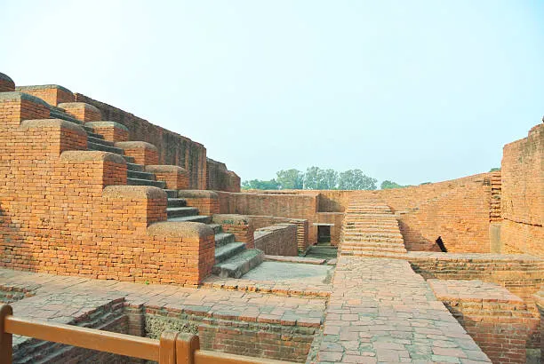
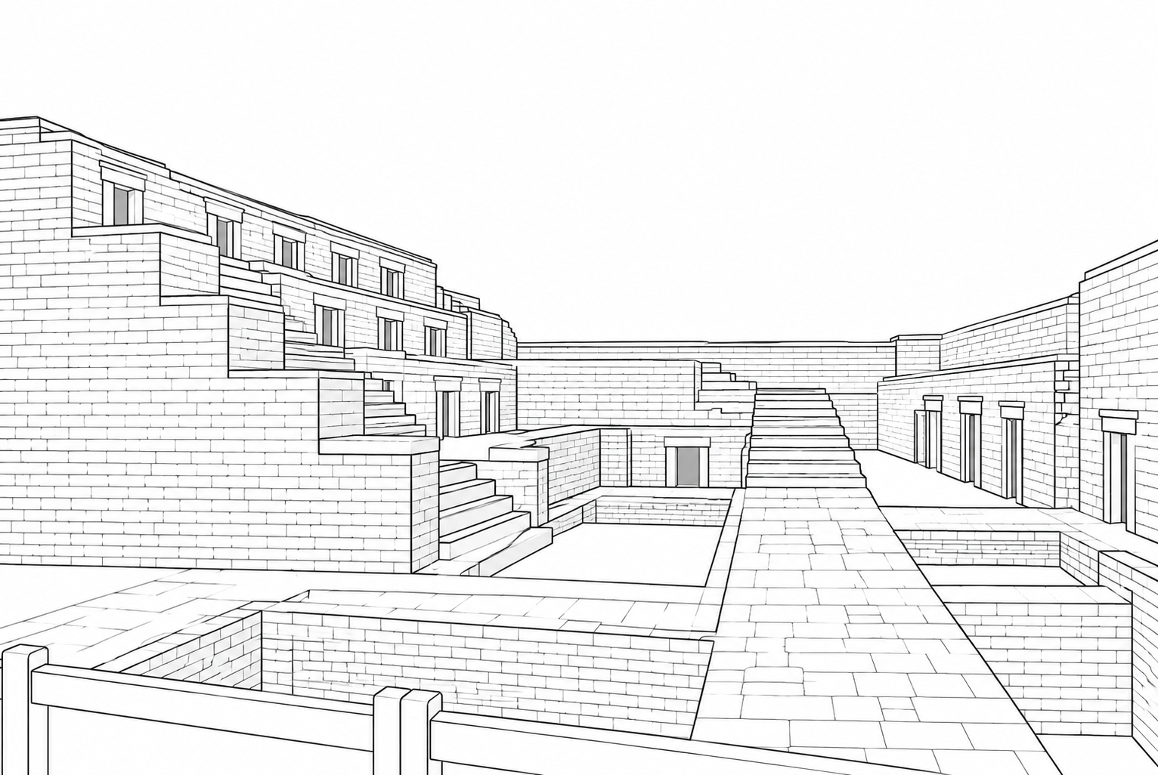

2. Temple Complexes
The temple structures were among the most prominent parts of Nalanda. Temple 3, in particular, is a major surviving archaeological structure. Its successive construction layers show that it was repeatedly enlarged and rebuilt over time.
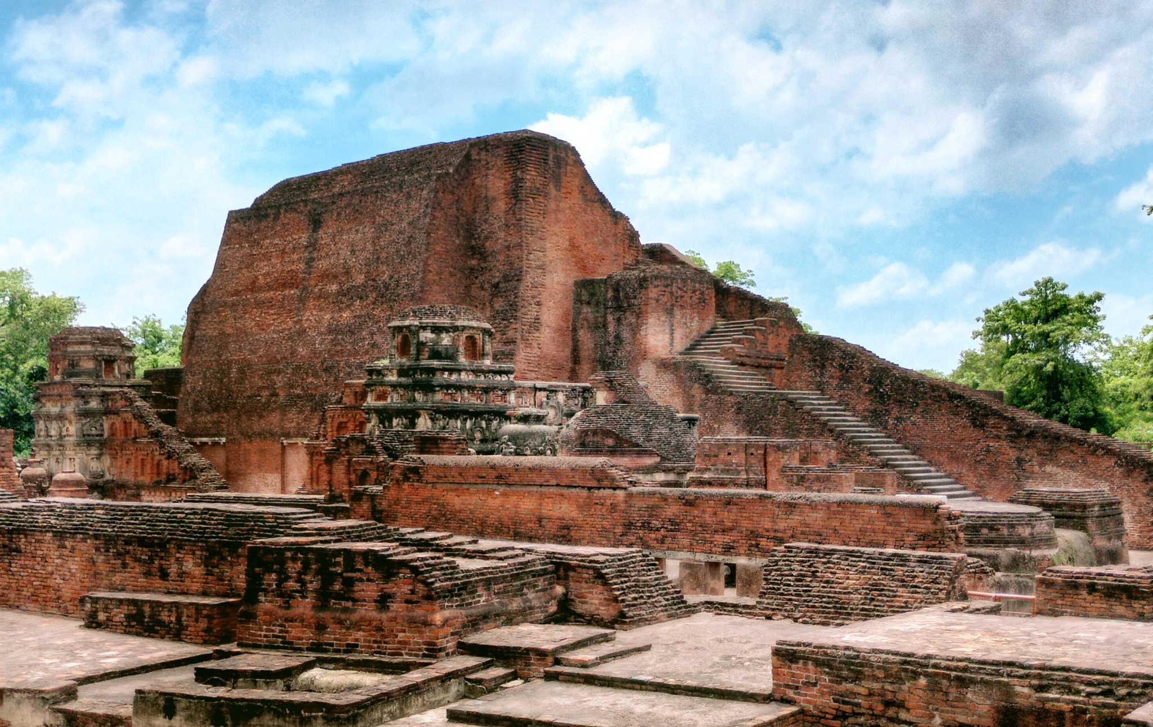


3. Main Shrine and Religious Structures
Nalanda contained shrines and religious buildings used for Buddhist worship and teaching. Many of these structures were damaged during periods of destruction and later deteriorated through neglect.

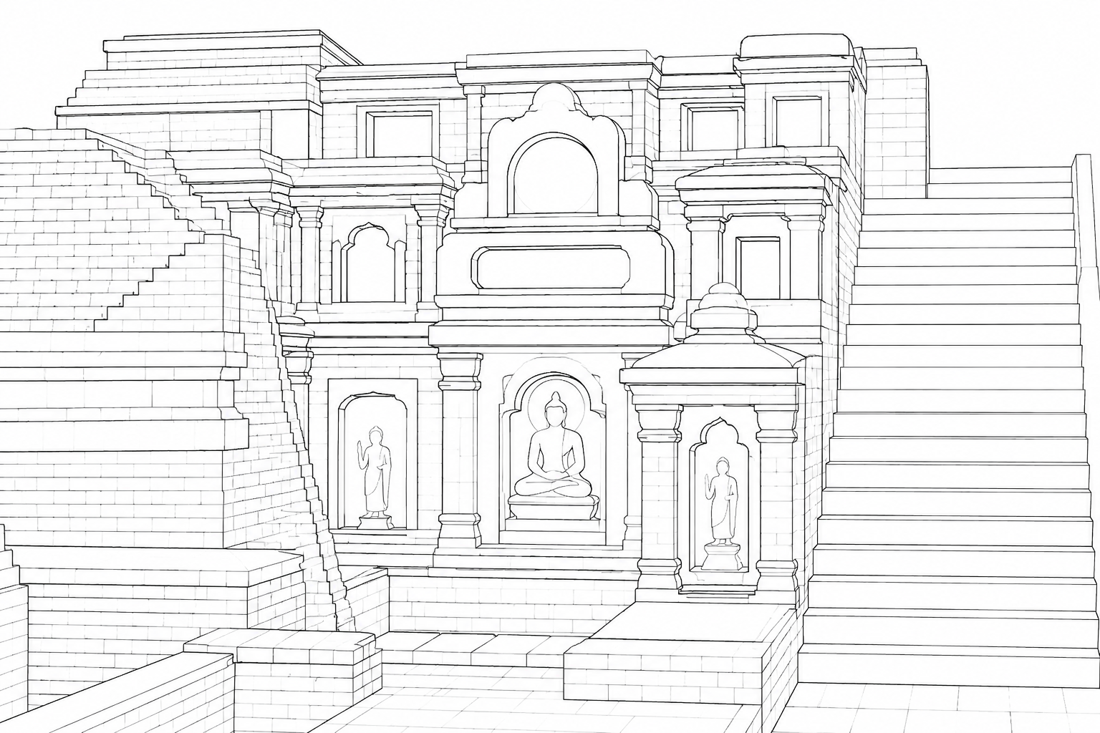
4. Library Buildings
Nalanda was traditionally associated with major library buildings and extensive manuscript collections. The loss of manuscripts is one of the most important cultural consequences associated with the destruction of Nalanda. The exact details of the traditional accounts about the libraries should be treated cautiously because archaeological evidence for their precise arrangement is limited.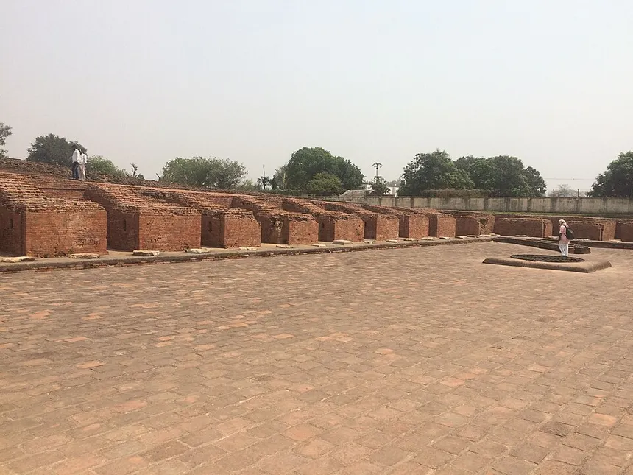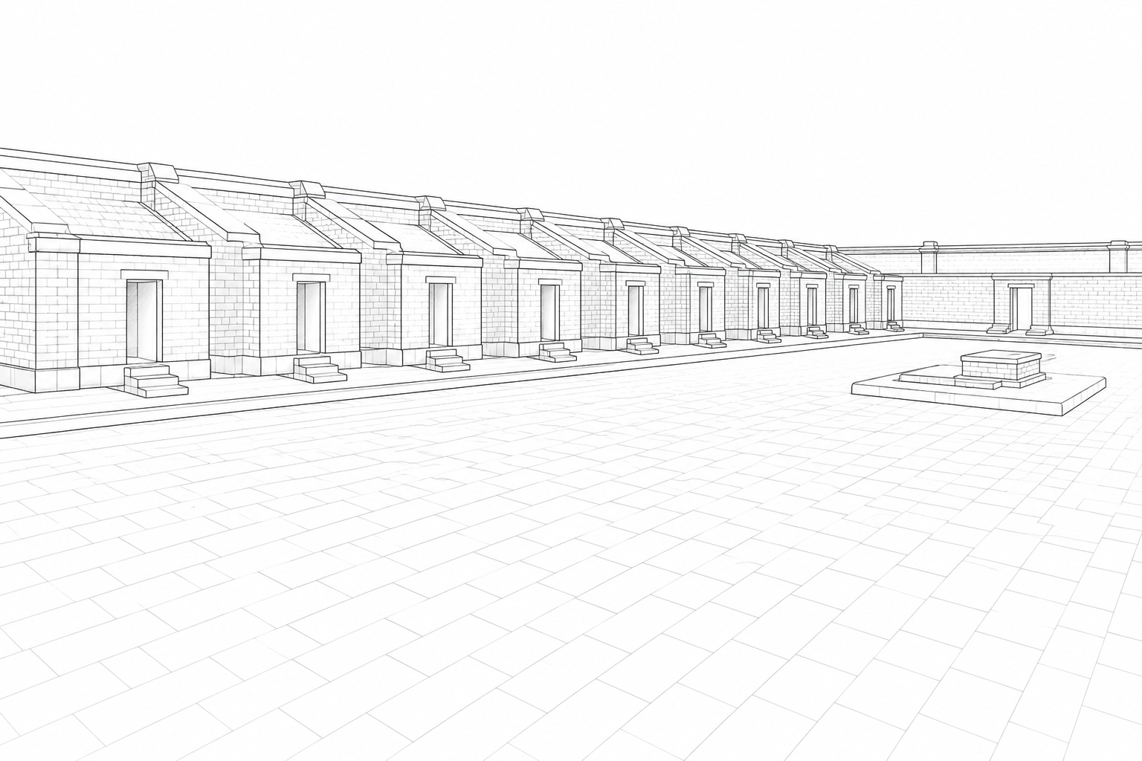

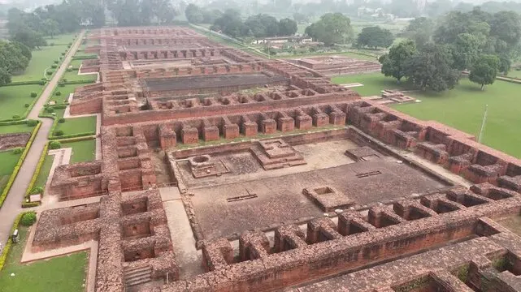

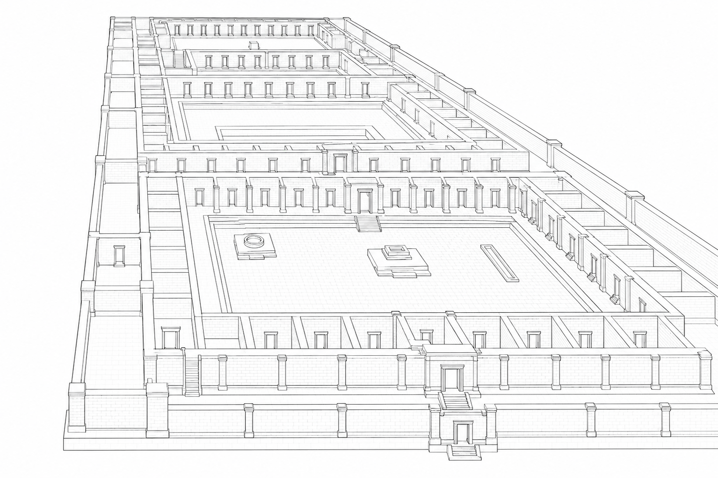

5. Residential Cells
The monasteries contained numerous small rooms for monks and students. Many walls and rooms survive only as foundations or partial brick structures.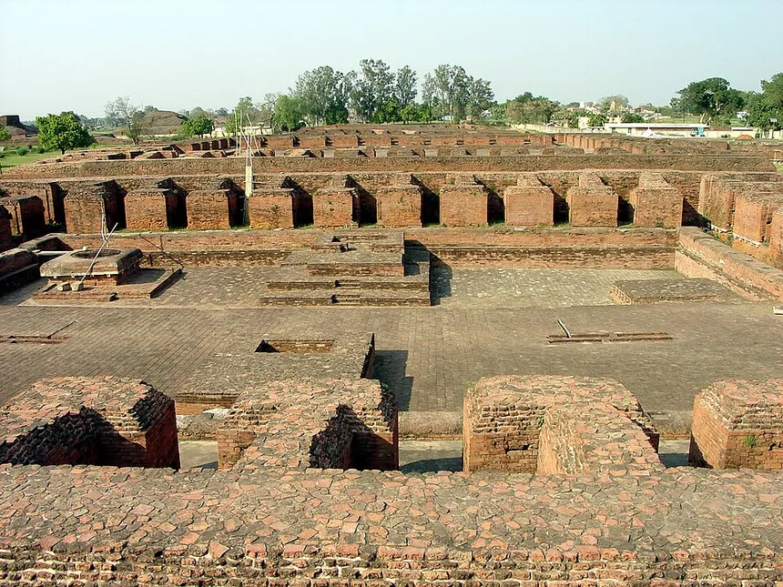
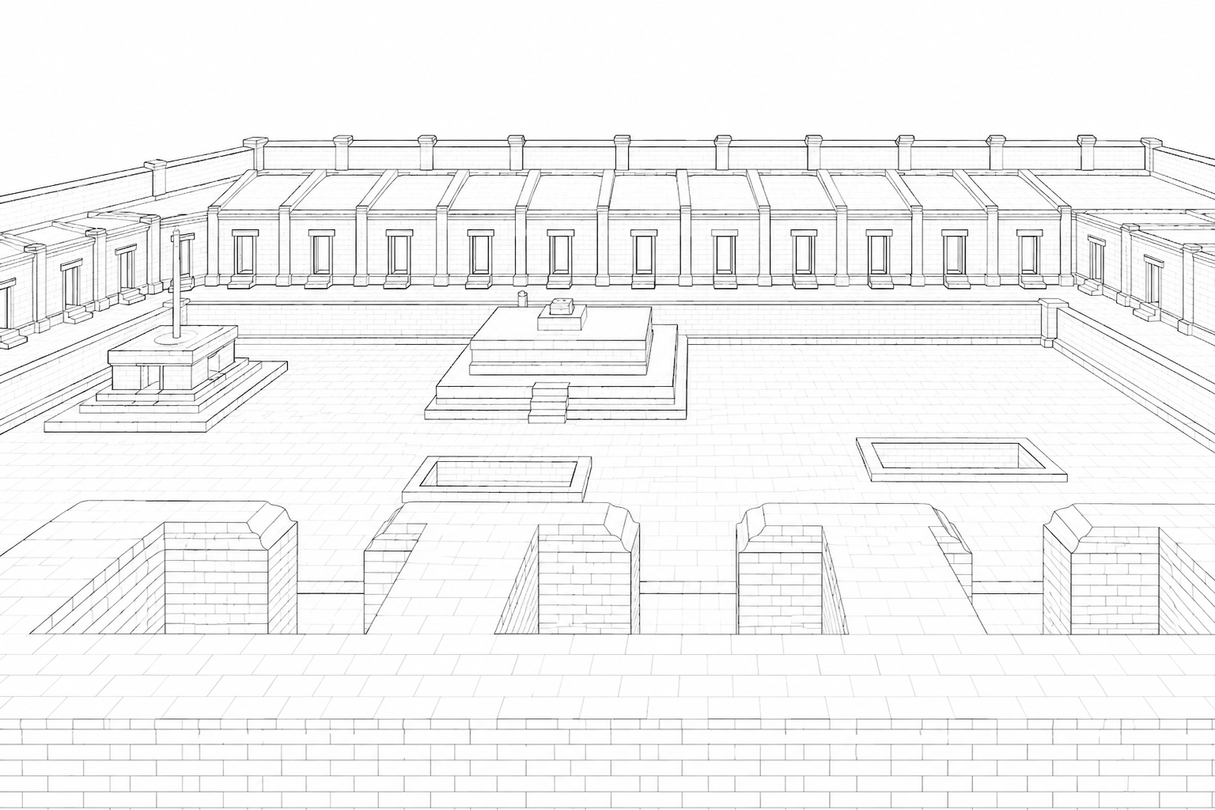

6. Courtyards and Assembly Areas
Large open courtyards were surrounded by residential and functional spaces. Their original architectural features were damaged and later affected by weathering and abandonment.
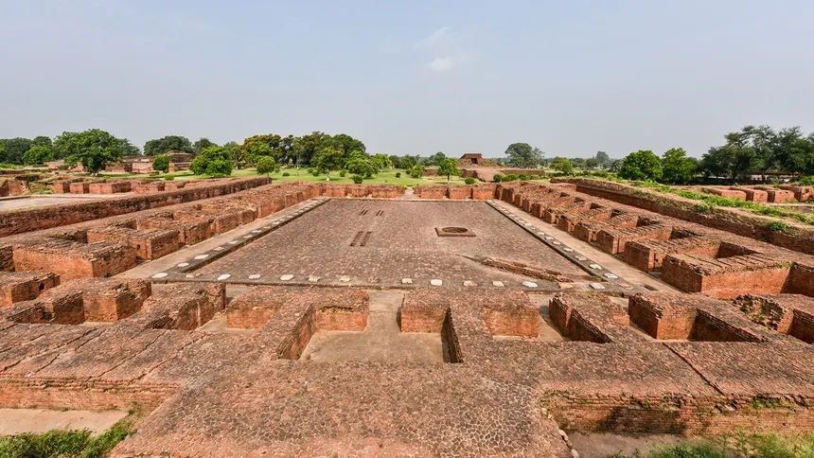
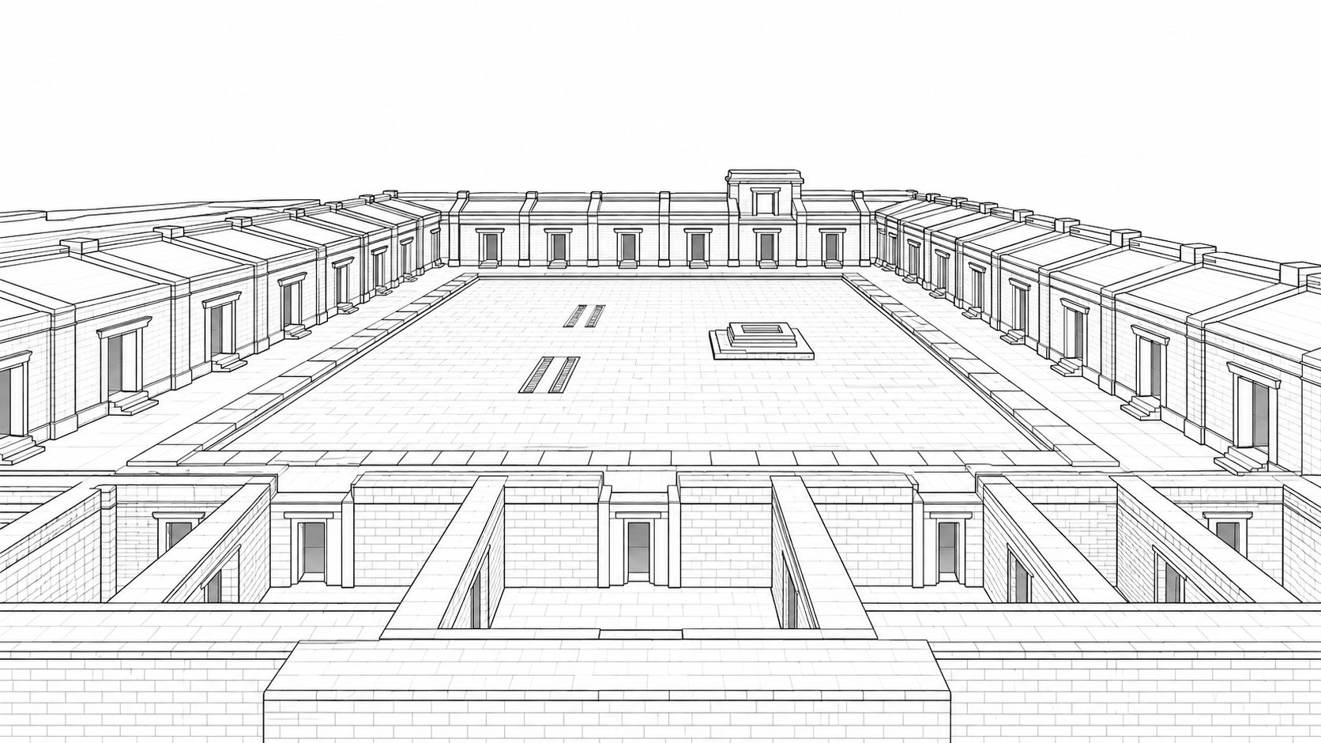

7. Entrance Gateways and Passageways
The monasteries had controlled entrances and connecting passages. Many original gateways and upper architectural elements have disappeared, leaving mainly foundations and lower walls.
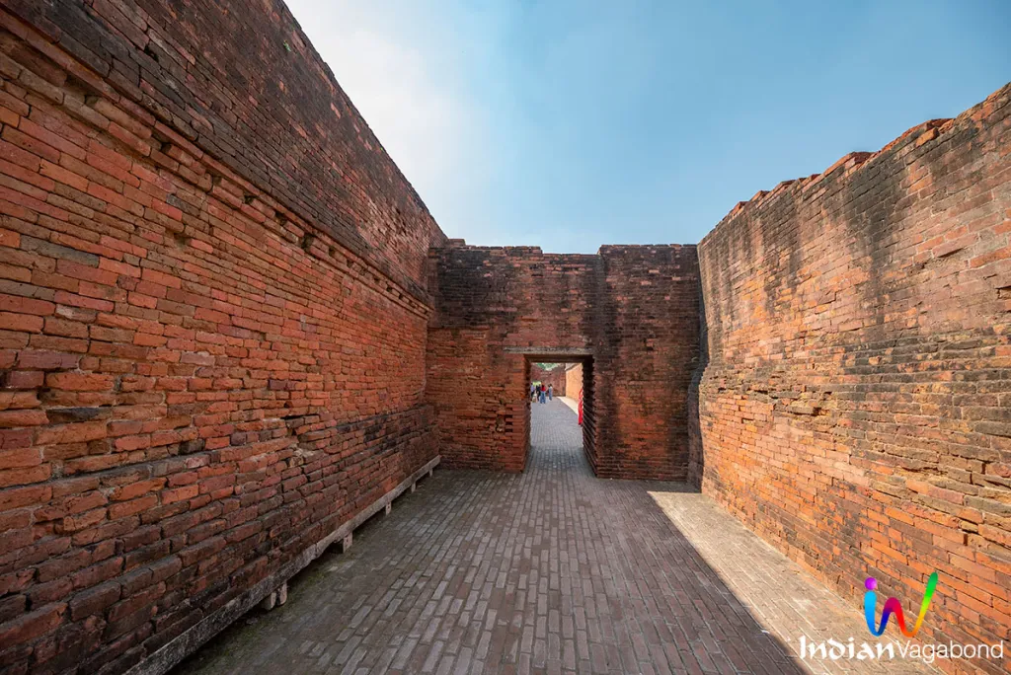
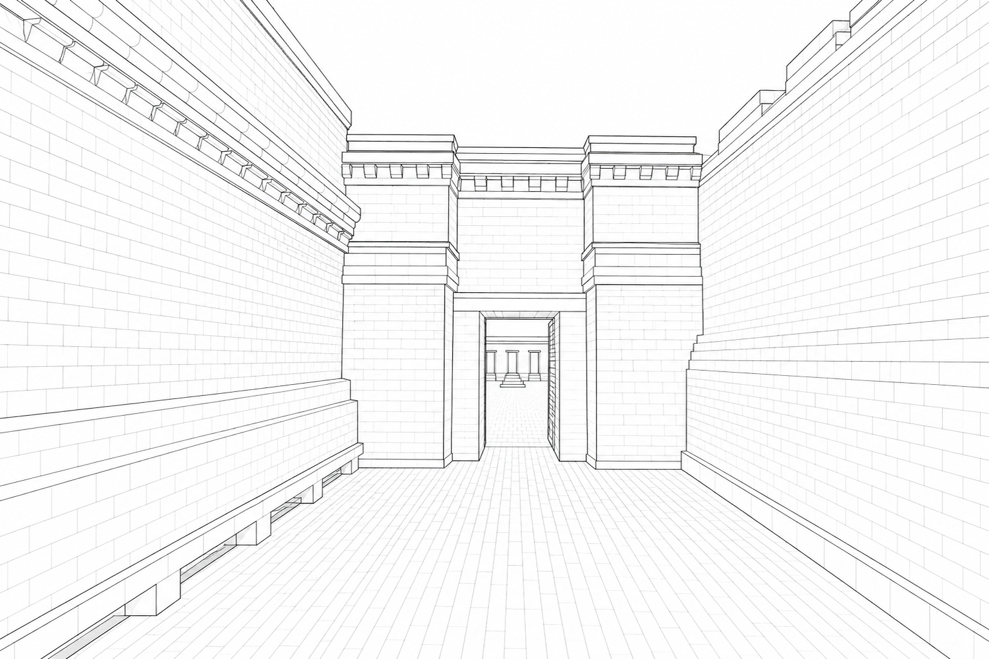

8. Water and Drainage Structures
Nalanda had arrangements for water management and drainage. Some survive archaeologically, while others were damaged or buried over centuries.
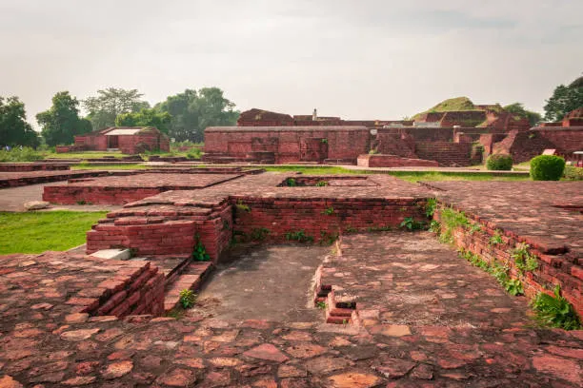
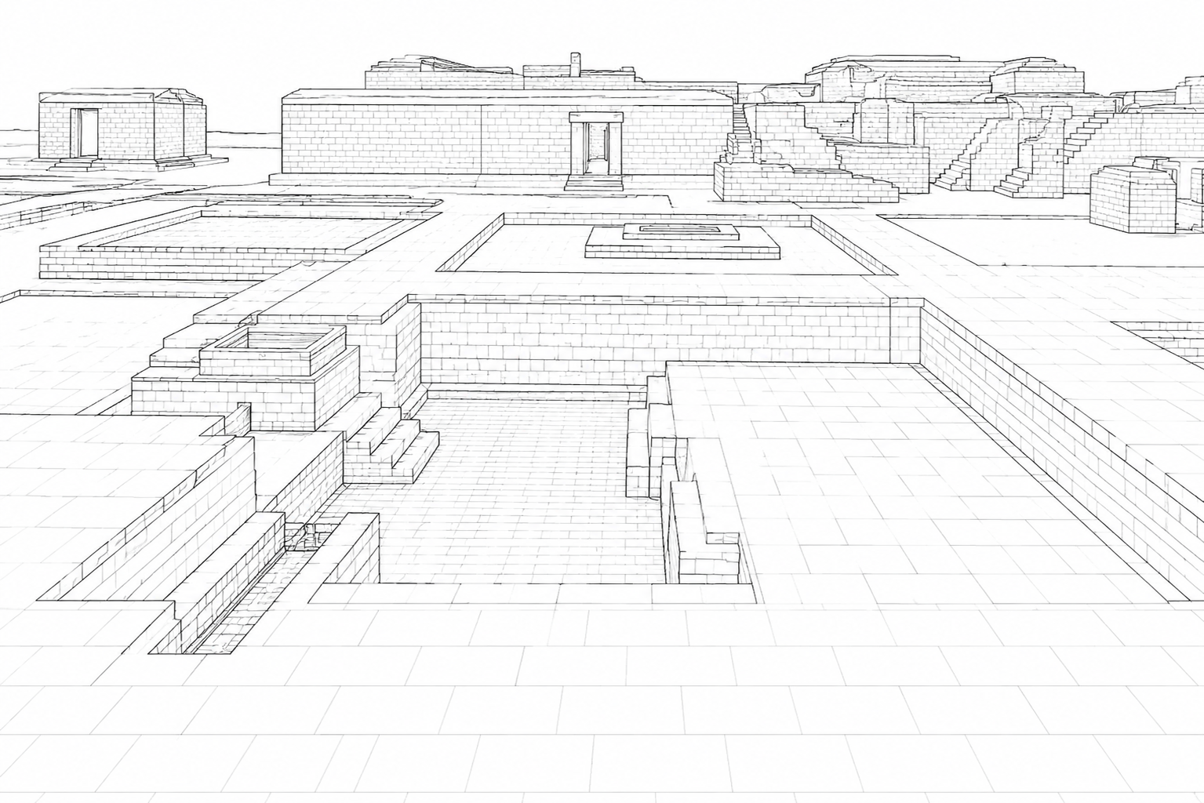

9. Sculptures and Decorative Elements
Numerous sculptures and architectural fragments were associated with the site. Damage, destruction and long-term exposure resulted in the loss of many original decorative features, although important examples survive.

10. Brick Architectural Elements
Nalanda was primarily constructed using brick. Walls, staircases, platforms and other brick structures were damaged by human activity and later weakened by rain, vegetation, soil accumulation and centuries of neglect.
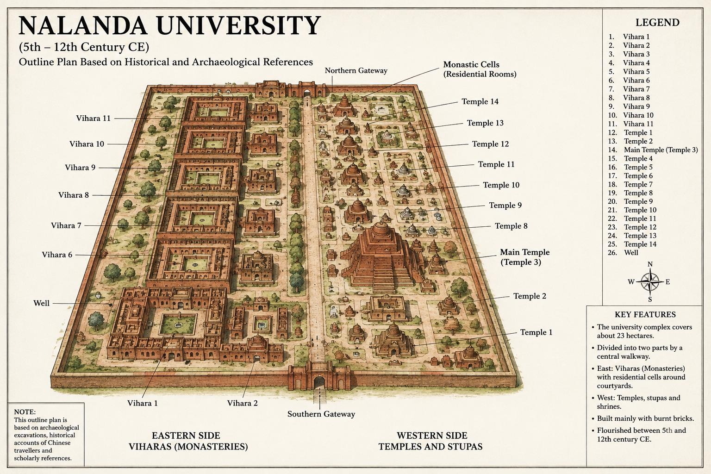
Reference videos:
The Archaeological Site of Nalanda
The video is a site documentary exploring the ruins of Nalanda, one of the oldest universities in the world. Located in the eastern Indian state of Bihar, this ancient monastic complex once attracted students from all across the globe (0:04).
The history, structure, and significance of the site can be summarized through these key areas:
History & Excavation
- Origin & Expansion: The major surviving buildings were constructed in the early 5th Century CE under the Gupta dynasty, with the complex expanding further over the next 700 years (0:20).
- Archaeological Digs: The Archaeological Survey of India conducted the first excavations between 1916 and 1937, followed by another round between 1974 and 1982 (0:29).
- Historical Records: Much of what we know about Nalanda comes from the 7th-century travel records of Xuanzang (Schwanzang), a Chinese Buddhist pilgrim (1:31).
- Destruction: Nalanda was destroyed around the end of the 13th Century CE when Muhammad Bhaktiyar Khalji, a Ghurid general, invaded and set fire to its legendary library (1:38).
Layout & Architectural Features
- Core Layout: The site spans an estimated 16 square kilometers (0:38). Excavations have revealed the core area of the Mega Monastery (Mahavihara), which features 11 layout-synchronized monasteries (viharas), alongside numerous stupas, chaityas, and shrines (0:47).
- Temples: The grounds contain the remains of six major brick temples (1:07). The most imposing is Temple Number Three, which highlights seven successive phases of construction (1:07).
- Stupa Structure: Stupa Number Five stands out as a magnificent structure with rows of stairways and sculptural panels (1:15).
Artifacts & Global Recognition
- Sculptures & Relics: Excavations have unearthed stone and bronze sculptures (including figures like Vajrapani, Manjushri, Marichi, and Vajrasarda), inscribed terracotta tablets, votive stupas, and wooden blocks (1:55). These pieces are preserved in the Archaeological Museum of Nalanda (2:22).
- UNESCO Status: In 2016, Nalanda was inscribed as a UNESCO World Heritage Site, recognizing its global importance as an ancient center of learning and culture (2:29).
Nalanda Mahavihara, the confluence of learning, spirituality and universal brotherhood !
This is especially valuable because it was produced by the Archaeological Survey of India (ASI). The film discusses the excavated remains and the historical and architectural importance of the site.
A related description of the ASI film notes that it uses drone footage and old excavation photographs, making it particularly useful for understanding the overall planning of the archaeological site.
It presents Nalanda as an extensive planned monastic institution and focuses on the archaeological remains rather than just telling the historical story. The aerial views help you understand the relationship between the monasteries and temple structures, while older excavation photographs give an idea of how the site was uncovered.

FQA – Visit to Nalanda Mahavihara

1. Where is Nalanda located?
Nalanda Mahavihara is located in Nalanda district of Bihar, India, in the historic Magadha region.

2. Why is Nalanda famous?
Nalanda is famous for being one of the ancient world's major monastic and scholastic centres, functioning for many centuries and attracting scholars from different parts of Asia.

3. When was Nalanda established?
The site has very early historical remains, but Nalanda developed into a major organised centre of learning particularly from around the 5th century CE.

4. Who founded Nalanda University?
Kumaragupta I of the Gupta dynasty is traditionally associated with the establishment and early development of Nalanda as a major Mahavihara.

5. What does "Mahavihara" mean?
Mahavihara means a great monastery. Nalanda was both a monastic institution and a centre of advanced learning.

6. What did students study at Nalanda?
Students studied subjects including Buddhist philosophy, logic, grammar, medicine, astronomy, mathematics and other systems of knowledge.

7. Who were some famous visitors to Nalanda?
The Chinese Buddhist scholars Xuanzang (Hiuen Tsang) and Yijing are among the best-known visitors associated with Nalanda.

8. What can visitors see at the archaeological site today?
Visitors can see remains of viharas, temples/chaityas, stupas, shrines, courtyards, residential cells and artistic remains. The protected archaeological property covers about 23 hectares and includes 11 viharas and 14 temples.

9. What is a Vihara?
A vihara was a Buddhist monastic building. At Nalanda, viharas contained residential rooms arranged around courtyards and were also used for educational and communal activities.

10. What is the most impressive structure at Nalanda?
Temple/Site No. 3 is one of the most prominent surviving structures. It is a large pyramidal brick temple surrounded by numerous votive stupas and sculptures.

11. What materials were used to construct Nalanda?
The main structures were constructed largely using brick, with important artistic elements made from stucco, stone and metal.

12. Why are the buildings in ruins today?
Nalanda was sacked and abandoned in the 13th century, after which the buildings gradually deteriorated. Political changes, attacks and loss of institutional support contributed to its decline.

13. Was Nalanda destroyed in only one attack?
It is better to describe its end as a process of destruction and decline, rather than assuming that everything disappeared in one single event. Historical and archaeological evidence indicates attacks followed by continued reduced use and eventual abandonment.

14. What happened to the famous Nalanda libraries?
Nalanda had important manuscript repositories. The destruction of the institution resulted in the loss of a substantial amount of intellectual and cultural material, although the exact details of the traditional accounts about the libraries should be treated cautiously.

15. How did Nalanda influence Asia?
Nalanda's educational, architectural and Buddhist traditions influenced institutions across South and Southeast Asia. Its methods of learning and debate also continued to influence Buddhist educational traditions.

16. When was Nalanda declared a UNESCO World Heritage Site?
The Archaeological Site of Nalanda Mahavihara was inscribed on the UNESCO World Heritage List in 2016.

17. Who protects the archaeological remains today?
The site is maintained and protected by the Archaeological Survey of India (ASI) under India's heritage-protection laws.

18. What makes Nalanda's architecture special?
Nalanda developed a distinctive planned arrangement of viharas and temple-like chaityas, with many viharas organised around rectangular courtyards. This architectural model influenced later Buddhist monastic institutions.

19. What should a visitor observe carefully?
During a visit, observe:
- Brick construction
- Monastery layouts
- Courtyards
- Staircases
- Residential cells
- Temple remains
- Stupas
- Drainage/water arrangements
- Sculptural remains
- Different layers of construction
These features help explain how Nalanda developed over several centuries.

20. What is the main lesson from visiting Nalanda?
Nalanda shows that ancient education was not limited to individual classrooms. It was an integrated system of residential life, scholarship, debate, religion, architecture and international cultural exchange. Its surviving ruins provide important evidence of this system

